**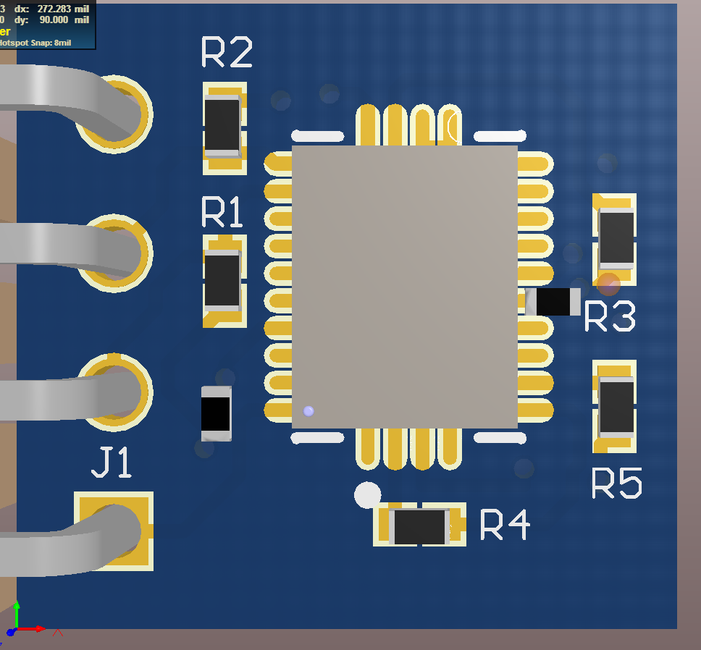

Install C2 capacitor on exposed pad for U1 Pin 9. Solder jumper wire onto U1 Pin 10 and attach to the other side of the capacitor.

Install C1 capacitor between VCC and GND vias. Solder in place.